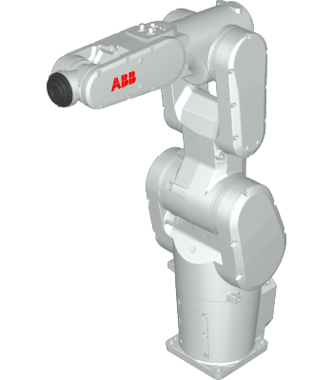

ABB ROBOTICS PROGRAMMING ASSIGNMENT
EMMANUEL ADOYE AMODU
@00698482
UNIVERSITY OF SALFORD

Table of Contents
INTRODUCTION - 2 -
Robot Motion - 3 -
Analysis of Motion and co-ordinate system. - 4 -
Move J: - 4 -
Move L - 4 -
Move C - 4 -
Co-ordinate System - 4 -
Base Frame Co-ordinate system - 4 -
World Co-ordinate system - 4 -
Tool centre point (TCP) Coordinate system - 5 -
Work Object co-ordinate system - 5 -
Zone Data - 5 -
Program set-up - 6 -
Program build up - 7 -
Shapes Routine - 8 -
Salford Routine - 8 -
Name Routine - 9 -
Running the program - 9 -
Conclusion - 10 -
References - 11 -

INTRODUCTION
Leading the way in robotics, machine automation, and digital services, ABB Robotics provides state-of-the-art solutions for a range of industries, including electronics, logistics, and the automotive sector. being one of the top providers of robotics and machine automation worldwide.
RobotStudio is the most popular offline programming and simulation tool used globally for robotic applications. Built on the most cutting-edge virtual controller technology available, the RobotStudio suite ensures that the exact motions executed by the robot match exactly with the motions you see on the computer screen. This innovative technology significantly decreases commissioning time and increases productivity by allowing you to design, test, and fine-tune your robot installation in a virtual setting. Programming and simulation can be done with RobotStudio desktop without interrupting with production.
One of ABB Robotics' newest series of 6-axis industrial robots, the IRB 1200 is designed specifically for manufacturers that use flexible robot-based automation, like the 3C industry. It has a payload capacity of between 5 and 7 kg. The robot can communicate widely with external systems and has an open structure specifically designed for flexible use. The robot is outfitted with the Robot Ware robot control software and the IRC5 Compact (IRC5C) or IRC5 (Single cabinet) controller. RobotWare facilitates all aspects of the robot system, including communication, application programme development and execution, motion control, and more.
There are two versions of the IRB 1200 that can be mounted in any orientation (around the X or Y axes) on the wall, the floor, or both. The handling ability and arm reach of the two robots differ from one another.
Robot type | Handling Capacity (Kg) | Reach (m)
IRB 1200 | 5 | 0.9
IRB 1200 | 7 | 0.7

We are utilising the IRB1200_5_0.9 robot for this report; it can handle up to 5 kg and has a 0.9 m (90 mm) reach. The robot's measurements are shown in the figure below:
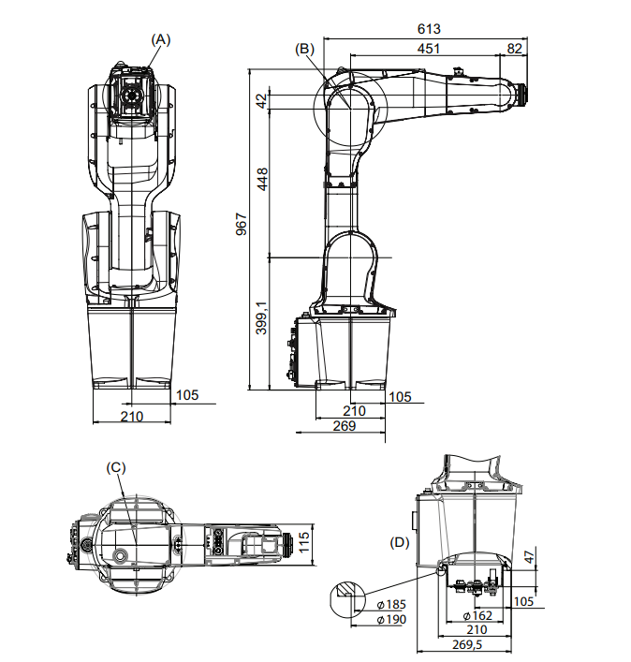
Fig 1 – Showing the dimensions of the Robot.

Robot Motion.
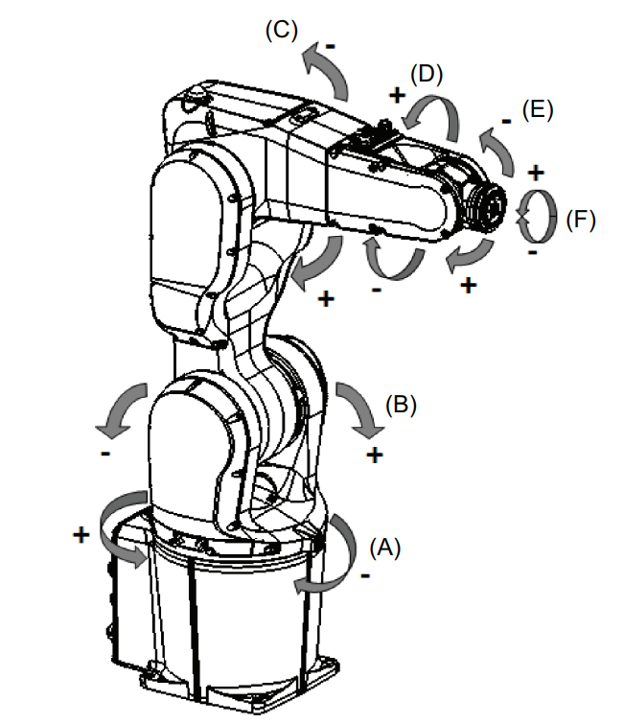
Fig 2. Showing the Axis of the Robot

Position | Description
A | Axis 1
B | Axis 2
C | Axis 3
D | Axis 4
E | Axis 5
F | Axis 6

Location of Motion | Type of motion
Axis 1 | Rotation motion
Axis 2 | Arm motion
Axis 3 | Arm motion
Axis 4 | Wrist motion
Axis 5 | Bend motion
Axis 6 | Turn motion

Analysis of Motion and co-ordinate system.
The project's goal is to programme the IRB1200 to draw three shapes (a dodecagon, a nonagon, and a square), write the word SALFORD and my name AMODU on three different pieces of paper using a pen attached to it.
Three movements were used to jog the robot about to achieve the aim of this project,
Move J: Move J is used to move the robot quickly between points when the TCP movement does not need to be in a straight line. The robot and external axes travel to the destination position along a non-linear path. At the same moment, all axis arrives at its destination. The robot could be moved from one point to another by using Move J (either when switching between shapes or work sheets).
Move L: This is utilised to transfer the tool centre point (TCP) linearly and quickly to a specified location. Tracing linearly programmed points or paths is done with move L.
Move C: With this technique, the tool centre point (TCP) can be moved along a curve at a predetermined speed and destination. To move in a circular direction, use the move c command.
Move J | Move L | Move C
Non-Linear | Linear path | Circular path
First movement operation | Used to draw the linear path | Used for Circular path
 | Used in the Main task | Used in the main task

Co-ordinate System
Base Frame Co-ordinate system: Every robot within the station possesses a base coordinate system, always situated at the robot's base.
World Co-ordinate system: The entire station or robot cell is represented by the world coordinate system.
Tool centre point (TCP) Coordinate system: The coordinate system for the tool's centre point, or TCP for short, is its centre point. For a single robot, multiple TCPs may be defined. Every robot has a single, set TCP at tool0, the tool mounting point. The robot moves the TCP to the designated location when a programme executes.
Work Object co-ordinate system: Typically, the physical work piece is represented by the work object. It is made up of two coordinate systems: the Object frame and the User frame. All targets (positions) in robot programming are connected to the work-object's object frame. The targets will be linked to the default Wobj0, which always aligns with the robot's base frame, if no other work-object is specified. If the work piece's location changes, using work-objects makes it possible to quickly modify robot programmes with an offset. Therefore, offline programmes can be calibrated using work-objects. 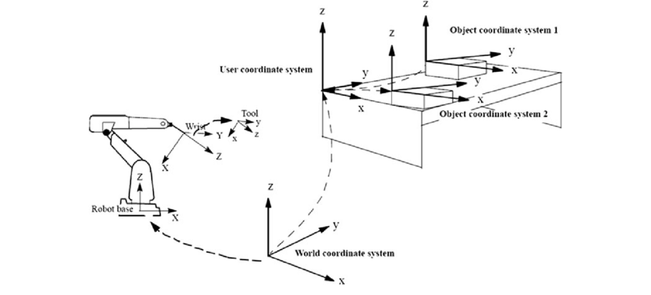
Fig 3. – Showing the Work object

Zone Data
Zone data is employed to determine the proximity required to the programmed position before initiating movement towards the subsequent position. Essentially, the Zone data describes a circular boundary around the specified point, with the radius explicitly defined in the code. For instance, Z30 denotes a zone data of 30, indicating the utilization of a radius of 30 units.
A larger zone data value increases the likelihood of the robot deviating from the programmed path. In our project, we employed various zone data settings, including Fine, Z0, and Z1, to ensure precise navigation and reach the designated points accurately.

Fig. 4 – Showing the zone data
The red line illustrates the deviation of the robot from the intended point as it enters the radius established by the Zone data.

Program set-up
Before developing the program, it is essential to construct the cell to match the provided figure. Follow the steps below to establish our working environment.
- A fresh solution was initiated in ABB RobotStudio by selecting the appropriate station and robot controller. The chosen robot model is the IRB 1200 5Kg 0.9m, and the version of RobotStudio employed is 6.04.00.01.
- Two CAD files, namely the Hardware set and Pen, were obtained from the RobotStudio assignment section on Blackboard. Subsequently, they were imported into RobotStudio using the import geometry function.
- The Pen and Robot were accurately positioned by assigning specific values for both position and orientation parameters. The robot's position was set to X,Y,Z (mm) = 0, 233, 298, with an orientation of -90 along the Z-axis. Simultaneously, the Pen was attached to the robot and rotated by 90 degrees along the X-axis to achieve the desired configuration.
- A new CAD piece, named "AMODU," was crafted using SolidWorks and subsequently imported into ABB RobotStudio. The CAD piece was saved in the .SAT format for compatibility and integration within the ABB studio environment.
- The hardware set featured three pieces of paper: one displaying various shapes, another with the word "SALFORD," and the last one bearing the name “AMODU”. A robot equipped with a pen was positioned on the hardware set, facing the correct direction.

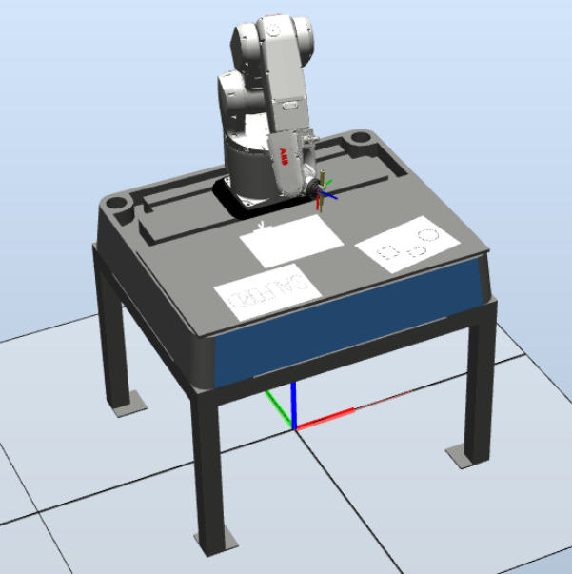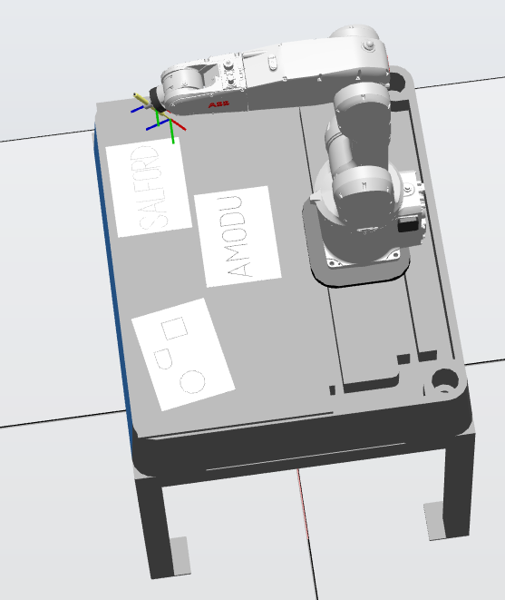
Fig. 5 – Showing the complete set up.

Program build up
The Flex Pendant was accessed, and a work object and a pen tool were established. The pen tool was configured with the following parameters. The work object was defined through the specification of three points, with two points situated along the X-axis and a single point along the Y-axis.
A tool pen was generated following these steps:
- Navigate to Program Data.
- Select Tool Data and then click Show Data.
- Click on New.
- Modify the tool name to "toolPen."
- Access Initial Value by clicking on it.
Position of TCP: X=100, Y=0, Z=20
Mass = 100 Gram or 0.1Kg
C.O.G: X=50, Y=0, Z=10
The work object was established through the following steps:
- Open the Program Data window in ABB.
- Double-click on wobjdata and click on New.
- Rename it to wobjPaper and click OK.
- With wobjPaper highlighted, choose Define from the Edit menu.
- From the pull-down menu, opt for the User method and select 3 points.
- Open the Jogging window and make sure the tool is set to toolPen and the Coordinate system is set to base.
- Select three points on the paper (2 points along X, 1 along Y) and click on Modify Position.
The program has been organized into four routines, adhering to good programming practice. Routines are concise sections of code that instruct the robot to execute specific tasks. These routines, named Name, Shape, and Salford, serve distinct purposes. Alongside the main routine, there are a total of four routines in the program. This modular structure allows for the convenient invocation of these routines within the main program whenever the corresponding actions are required.
- Main Routine
- Name Routine
- Salford Routine
- Shapes Routine

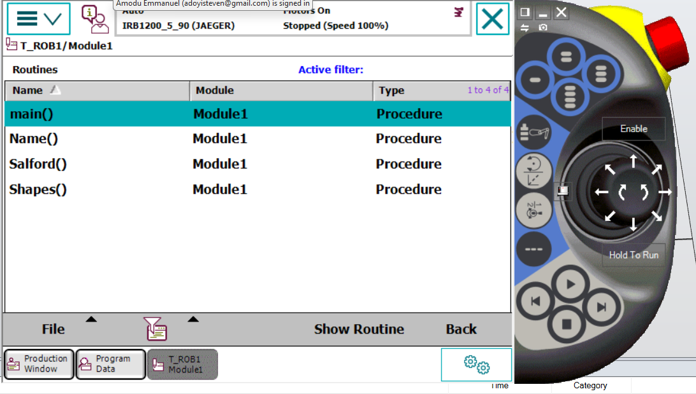
Fig. 6 – Showing the routines on the pendant
An interactive interface was developed to prompt the user for their desired drawing choice, whether it's Shapes, Salford, or a specific name. The work object and the tool pen were then designated before initiating the drawing process. A velocity setting of 100 (V100) was chosen, and the zone data was customized according to the nature of the path being traced.
For Move J and Linear movements covering longer distances, a Fine zone data was employed to ensure the robot precisely reaches the intended points. Conversely, shorter linear movements utilized Zone data settings of Z0 and Z1 to optimize the path execution. This strategic use of zone data enhances the accuracy and efficiency of the robot's movements based on the specific requirements of the drawing task.

Shapes Routine
The initial step involves executing a Move J to position the robot precisely at the desired starting point. Subsequently, the Move L is employed to guide the robot along the designated path, tracing the lines that form the shapes. A deliberate 2-second delay has been incorporated into the program. Following the completion of drawing a shape, a Move J is utilized to relocate the robot to a designated home position before proceeding to draw the next shape.
The process is repeated as necessary, with the Move L facilitating the tracing of lines for each shape. Once all the shapes have been drawn, the robot is directed back to a home position. This systematic approach ensures precise movement and organized execution of the drawing tasks.

Salford Routine
The initial movement involves executing a Move J, transitioning the robot from its home position to the specified starting point. Subsequently, the Move L is employed to follow and trace along the designated path. The font chosen for the Salford text comprises a combination of short dashes and long lines, forming each letter.
To optimize the robot's movement based on the characteristics of the path, the zone data is dynamically adjusted between Fine and Z1 settings. This strategic use of zone data enhances precision and efficiency in executing the varied movements required for the Salford font.

Name Routine
The initial action involves executing a Move J, guiding the robot from its home position to the specified starting point. Subsequently, the Move L is employed to intricately trace along the designated path. The Name font is characterized by a combination of short dashes and long lines, forming each letter.
To maintain precision and accuracy throughout the entire tracing process, the zone data is consistently set to Fine.

Running the program
Here's a step-by-step guide for the described process:
- On the Flex Pendant, switch the controller to manual mode (B) and click Enable (A). Ensure the motor is turned on, and an "A motor on" status should be displayed at the top of the Flex Pendant.
- In the program editor, select Debug and then PP to Main.
- Click the play button (C) to run the program. A user interface will appear, prompting you to choose a program routine (SALFORD, SHAPES, or NAME).
- Select your desired program choice, and enjoy observing the sequential movement of the robot as it executes the chosen routine.
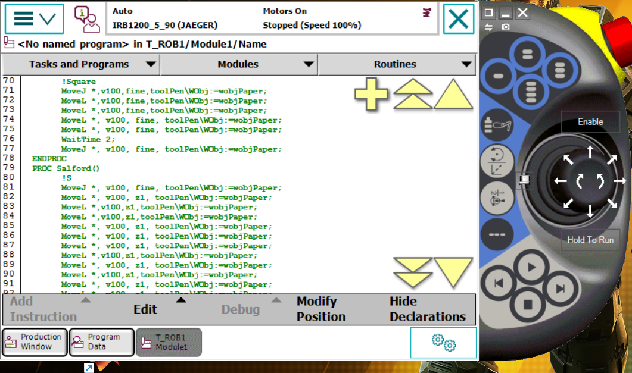
Fig. 7 – Showing controls.
Here's a breakdown of the labelled buttons:
- Button to Switch to Manual: This button is employed to transition the robot system into manual mode, enabling manual control.
- Enable Button: This button is used to enable the robot system, allowing it to be operational.
- Buttons to Start the Program, Stop, Next Line, Previous Line:
- Start Button: Initiates the execution of the programmed routine or sequence.
- Stop Button: Halts the execution of the program or routine.
- Next Line Button: Advances the program to the next line of code for manual step-through.
- Previous Line Button: Moves the program back to the preceding line of code during manual step-through.

Conclusion
On completion of this Assignment/project, I learnt the following:
- I was able to program an ABB Robot by the ABB Robotic Studio software user interfaces/simulation environment.
- I learnt how to use the various instructions Move L, Move C, and move J as well as understand their purpose/Application.
- I learnt how to effectively use Zone data and also adjust the velocity of the robot based on the work object.
- How to jog and use the different tools/components on the Flex pendant.
- How to implement ZONEDATA and Velocity in a program as well as their purpose.
- The difference between Synchronizing to station and rapid and how to import and export a program I.e., Pack and Go.
- How to run a program using Simulation and also in real life application.

References
Coordinate systems. https://developercenter.robotstudio.com/api/robotstudio/articles/Concepts/Math/Coordinate-Systems.html
Industrial Robot Supplier and manufacturer: ABB Robotics. Robotics. (2023, August 3). https://new.abb.com/products/robotics
Robot-Studio Suite. https://new.abb.com/products/robotics/robotstudio
ABB Robotics Technical Reference Manual RAPID Instructions, Functions and Data Types.
ABB RobotStudio course 2023-2024. https://blackboard.salford.ac.uk/ultra/courses/_182764_1/outline/file/_9435446_1
ABB Robotics Technical Reference Manual RAPID Instructions, Functions and Data-Types. https://blackboard.salford.ac.uk/ultra/courses/_182764_1/outline/file/_9435452_1

APPENDIX
ABB ROBOTICS CODE.
MODULE Module1
TASK PERS tooldata toolPen:=[TRUE,[[100,0,20],[1,0,0,0]],[0.1,[50,0,10],[1,0,0,0],0,0,0]];
TASK PERS wobjdata wobjPaper:=[FALSE,TRUE,"",[[523.36,442.253,103.572],[0.0574373,-0.785768,0.614209,-0.0448991]],[[0,0,0],[1,0,0,0]]];
VAR num Coursework:=0;
VAR num Coursework1:=0;
!***********************************************************
!
! Module: Module1
!
! Description:
! <Insert description here>
!
! Author: user1
!
! Version: 1.0
!
!***********************************************************

!***********************************************************
!
! Procedure main
!
! This is the entry point of your program
!
!***********************************************************
PROC main()
TPErase;
TPWrite "Emmanuel Amodu Coursework";
TPReadFK Coursework, "What do you want to draw?", "Shapes", "Salford", "Name", stEmpty, stEmpty;
TEST Coursework
CASE 1:
Shapes;
CASE 2:
Salford;
CASE 3:
Name;
ENDTEST
ENDPROC
PROC Shapes()
!Dodecagon
MoveJ [[52.92,-0.34,104.66],[0.545497,0.416491,-0.528594,0.499556],[0,0,-1,1],[9E+09,9E+09,9E+09,9E+09,9E+09,9E+09]], v100, z1, toolPen\WObj:=wobjPaper;
MoveL [[35.43,3.11,104.15],[0.545498,0.41649,-0.528594,0.499556],[0,0,-1,1],[9E+09,9E+09,9E+09,9E+09,9E+09,9E+09]], v100, z1, toolPen\WObj:=wobjPaper;
MoveL [[22.06,14.53,102.47],[0.545497,0.416491,-0.528594,0.499556],[0,0,-1,1],[9E+09,9E+09,9E+09,9E+09,9E+09,9E+09]], v100, z1, toolPen\WObj:=wobjPaper;
MoveL [[16.21,31.07,100.04],[0.545497,0.416491,-0.528595,0.499555],[0,0,-1,1],[9E+09,9E+09,9E+09,9E+09,9E+09,9E+09]], v100, z1, toolPen\WObj:=wobjPaper;
MoveL [[19.54,48.7,97.45],[0.545496,0.416492,-0.528595,0.499555],[0,0,-1,1],[9E+09,9E+09,9E+09,9E+09,9E+09,9E+09]],v100,z1,toolPen\WObj:=wobjPaper;
MoveL [[31.34,61.88,95.51],[0.545496,0.416492,-0.528596,0.499555],[0,0,0,1],[9E+09,9E+09,9E+09,9E+09,9E+09,9E+09]], v100, z1, toolPen\WObj:=wobjPaper;
MoveL [[47.9,67.58,94.68],[0.545496,0.416492,-0.528596,0.499555],[0,0,0,1],[9E+09,9E+09,9E+09,9E+09,9E+09,9E+09]],v100,z1,toolPen\WObj:=wobjPaper;
MoveL [[65.79,64.06,95.19],[0.545495,0.416493,-0.528597,0.499554],[0,0,0,1],[9E+09,9E+09,9E+09,9E+09,9E+09,9E+09]], v100, z1, toolPen\WObj:=wobjPaper;
MoveL [[79.25,52.63,96.87],[0.545496,0.416492,-0.528596,0.499555],[0,0,0,1],[9E+09,9E+09,9E+09,9E+09,9E+09,9E+09]], v100, z1, toolPen\WObj:=wobjPaper;
MoveL [[85.03,35.9,99.33],[0.545494,0.416493,-0.528598,0.499554],[0,0,0,1],[9E+09,9E+09,9E+09,9E+09,9E+09,9E+09]],v100,z1,toolPen\WObj:=wobjPaper;
MoveL [[81.44,18.46,101.89],[0.545495,0.416492,-0.528597,0.499554],[0,0,0,1],[9E+09,9E+09,9E+09,9E+09,9E+09,9E+09]], v100, z1, toolPen\WObj:=wobjPaper;
MoveL [[70.11,5.57,103.79],[0.545495,0.416492,-0.528598,0.499553],[0,0,0,1],[9E+09,9E+09,9E+09,9E+09,9E+09,9E+09]], v100, z1, toolPen\WObj:=wobjPaper;
MoveL [[52.81,-0.43,104.67],[0.545494,0.416493,-0.528599,0.499553],[0,0,-1,1],[9E+09,9E+09,9E+09,9E+09,9E+09,9E+09]], v100, z1, toolPen\WObj:=wobjPaper;
WaitTime 2;
MoveJ [[52.81,-1.55,97.08],[0.545494,0.416493,-0.528599,0.499553],[0,0,-1,1],[9E+09,9E+09,9E+09,9E+09,9E+09,9E+09]], v100, z1, toolPen\WObj:=wobjPaper;
!Nonagon
MoveJ [[133.28,4.32,103.87],[0.545494,0.416492,-0.528599,0.499553],[0,0,0,1],[9E+09,9E+09,9E+09,9E+09,9E+09,9E+09]], v100, fine, toolPen\WObj:=wobjPaper;
MoveL [[123.45,0.57,104.42],[0.545494,0.416493,-0.528598,0.499553],[0,0,0,1],[9E+09,9E+09,9E+09,9E+09,9E+09,9E+09]], v100, z1, toolPen\WObj:=wobjPaper;
MoveL [[116.78,-6.86,105.51],[0.545494,0.416493,-0.528599,0.499553],[0,0,0,1],[9E+09,9E+09,9E+09,9E+09,9E+09,9E+09]], v100, z1, toolPen\WObj:=wobjPaper;
MoveL [[115.09,-16.72,106.96],[0.545494,0.416493,-0.528598,0.499553],[0,0,0,1],[9E+09,9E+09,9E+09,9E+09,9E+09,9E+09]], v100, z1, toolPen\WObj:=wobjPaper;
MoveL [[118.32,-26.18,108.35],[0.545494,0.416493,-0.528598,0.499553],[0,0,0,1],[9E+09,9E+09,9E+09,9E+09,9E+09,9E+09]], v100, z1, toolPen\WObj:=wobjPaper;
MoveL [[125.63,-32.47,109.27],[0.545494,0.416493,-0.528599,0.499553],[0,0,0,1],[9E+09,9E+09,9E+09,9E+09,9E+09,9E+09]], v100, z1, toolPen\WObj:=wobjPaper;
MoveL [[135.23,-34.33,109.55],[0.545494,0.416493,-0.528599,0.499553],[0,0,0,1],[9E+09,9E+09,9E+09,9E+09,9E+09,9E+09]], v100, z1, toolPen\WObj:=wobjPaper;
MoveL [[175.17,-31.75,109.17],[0.545494,0.416493,-0.528599,0.499553],[0,0,0,1],[9E+09,9E+09,9E+09,9E+09,9E+09,9E+09]], v100, z0, toolPen\WObj:=wobjPaper;
MoveL [[172.41,6.1,103.6],[0.545494,0.416493,-0.528598,0.499553],[0,0,0,1],[9E+09,9E+09,9E+09,9E+09,9E+09,9E+09]],v100,z0,toolPen\WObj:=wobjPaper;
MoveL [[132.59,3.92,103.92],[0.545494,0.416493,-0.528599,0.499553],[0,0,0,1],[9E+09,9E+09,9E+09,9E+09,9E+09,9E+09]], v100, z0, toolPen\WObj:=wobjPaper;
WaitTime 2;
MoveJ [[132.59,3.35,100.07],[0.545494,0.416493,-0.528599,0.499553],[0,0,0,1],[9E+09,9E+09,9E+09,9E+09,9E+09,9E+09]], v100, z0, toolPen\WObj:=wobjPaper;
!Square
MoveJ [[198.2,14.61,102.39],[0.545494,0.416493,-0.528598,0.499554],[0,-1,0,1],[9E+09,9E+09,9E+09,9E+09,9E+09,9E+09]],v100,fine,toolPen\WObj:=wobjPaper;
MoveL [[251.9,18.04,101.88],[0.545494,0.416492,-0.528598,0.499554],[0,-1,0,1],[9E+09,9E+09,9E+09,9E+09,9E+09,9E+09]],v100,fine,toolPen\WObj:=wobjPaper;
MoveL [[247.57,75.77,93.4],[0.545495,0.416492,-0.528598,0.499554],[0,-1,0,1],[9E+09,9E+09,9E+09,9E+09,9E+09,9E+09]],v100,fine,toolPen\WObj:=wobjPaper;
MoveL [[193.76,72.29,93.91],[0.545494,0.416492,-0.528599,0.499553],[0,0,0,1],[9E+09,9E+09,9E+09,9E+09,9E+09,9E+09]], v100, fine, toolPen\WObj:=wobjPaper;
MoveL [[198.12,14.69,102.37],[0.545494,0.416492,-0.528599,0.499553],[0,-1,0,1],[9E+09,9E+09,9E+09,9E+09,9E+09,9E+09]], v100, fine, toolPen\WObj:=wobjPaper;
WaitTime 2;
MoveJ [[198.12,11.73,82.21],[0.545494,0.416493,-0.528599,0.499553],[0,-1,0,1],[9E+09,9E+09,9E+09,9E+09,9E+09,9E+09]], v100, fine, toolPen\WObj:=wobjPaper;
ENDPROC
PROC Salford()
!S
MoveJ [[581.81,95.35,90.58],[0.545495,0.416491,-0.528598,0.499554],[-1,-1,0,1],[9E+09,9E+09,9E+09,9E+09,9E+09,9E+09]], v100, fine, toolPen\WObj:=wobjPaper;
MoveL [[581.42,85.11,92.09],[0.545495,0.41649,-0.528598,0.499555],[-1,-1,0,1],[9E+09,9E+09,9E+09,9E+09,9E+09,9E+09]], v100, z1, toolPen\WObj:=wobjPaper;
MoveL [[576.2,76.52,93.35],[0.545495,0.41649,-0.528598,0.499555],[-1,-1,0,1],[9E+09,9E+09,9E+09,9E+09,9E+09,9E+09]],v100,z1,toolPen\WObj:=wobjPaper;
MoveL [[567,71.92,94.03],[0.545495,0.41649,-0.528598,0.499555],[-1,-1,0,1],[9E+09,9E+09,9E+09,9E+09,9E+09,9E+09]],v100,z1,toolPen\WObj:=wobjPaper;
MoveL [[557.14,72.15,93.99],[0.545495,0.41649,-0.528598,0.499555],[-1,-1,0,1],[9E+09,9E+09,9E+09,9E+09,9E+09,9E+09]], v100, z1, toolPen\WObj:=wobjPaper;
MoveL [[548.74,77.15,93.26],[0.545495,0.41649,-0.528598,0.499555],[-1,-1,0,1],[9E+09,9E+09,9E+09,9E+09,9E+09,9E+09]], v100, z1, toolPen\WObj:=wobjPaper;
MoveL [[544.07,85.63,92.01],[0.545495,0.41649,-0.528598,0.499555],[-1,-1,0,1],[9E+09,9E+09,9E+09,9E+09,9E+09,9E+09]], v100, z1, toolPen\WObj:=wobjPaper;
MoveL [[572.16,134.01,84.9],[0.545495,0.416491,-0.528598,0.499555],[-1,-1,0,1],[9E+09,9E+09,9E+09,9E+09,9E+09,9E+09]],v100,z1,toolPen\WObj:=wobjPaper;
MoveL [[567.66,142.48,83.66],[0.545495,0.41649,-0.528598,0.499555],[-1,-1,0,1],[9E+09,9E+09,9E+09,9E+09,9E+09,9E+09]], v100, z1, toolPen\WObj:=wobjPaper;
MoveL [[559.24,147.59,82.9],[0.545494,0.416491,-0.528598,0.499555],[-1,-1,0,1],[9E+09,9E+09,9E+09,9E+09,9E+09,9E+09]],v100,z1,toolPen\WObj:=wobjPaper;
MoveL [[548.99,147.74,82.88],[0.545495,0.41649,-0.528598,0.499555],[-1,-1,0,1],[9E+09,9E+09,9E+09,9E+09,9E+09,9E+09]], v100, z1, toolPen\WObj:=wobjPaper;
MoveL [[540.15,143.17,83.56],[0.545495,0.41649,-0.528597,0.499556],[-1,-1,0,1],[9E+09,9E+09,9E+09,9E+09,9E+09,9E+09]], v100, z1, toolPen\WObj:=wobjPaper;
MoveL [[534.8,134.25,84.87],[0.545495,0.41649,-0.528597,0.499556],[-1,-1,0,1],[9E+09,9E+09,9E+09,9E+09,9E+09,9E+09]],v100,z1,toolPen\WObj:=wobjPaper;
MoveL [[534.52,124.69,86.27],[0.545495,0.416489,-0.528597,0.499557],[-1,-1,0,1],[9E+09,9E+09,9E+09,9E+09,9E+09,9E+09]], v100, z1, toolPen\WObj:=wobjPaper;
MoveJ [[534.52,124.4,84.26],[0.545495,0.416489,-0.528597,0.499556],[-1,-1,0,1],[9E+09,9E+09,9E+09,9E+09,9E+09,9E+09]],v100,z1,toolPen\WObj:=wobjPaper;
!A
MoveJ [[573.96,153.33,81.87],[0.545496,0.416489,-0.528596,0.499557],[-1,-1,0,1],[9E+09,9E+09,9E+09,9E+09,9E+09,9E+09]], v100, fine, toolPen\WObj:=wobjPaper;
MoveL [[610.72,83.51,92.14],[0.545496,0.416489,-0.528596,0.499557],[-1,-1,0,1],[9E+09,9E+09,9E+09,9E+09,9E+09,9E+09]], v100, fine, toolPen\WObj:=wobjPaper;
MoveL [[611.65,162.52,80.52],[0.545496,0.416489,-0.528597,0.499557],[-1,-1,0,1],[9E+09,9E+09,9E+09,9E+09,9E+09,9E+09]], v100, fine, toolPen\WObj:=wobjPaper;
MoveJ [[611.68,162.29,79.89],[0.545496,0.416489,-0.528596,0.499557],[-1,-1,0,1],[9E+09,9E+09,9E+09,9E+09,9E+09,9E+09]], v100, fine, toolPen\WObj:=wobjPaper;
MoveJ [[611.18,131.81,85.18],[0.545496,0.416488,-0.528596,0.499558],[-1,-1,0,1],[9E+09,9E+09,9E+09,9E+09,9E+09,9E+09]], v100, fine, toolPen\WObj:=wobjPaper;
MoveL [[588.57,126.24,86],[0.545496,0.416488,-0.528596,0.499558],[-1,-1,0,1],[9E+09,9E+09,9E+09,9E+09,9E+09,9E+09]],v100,fine,toolPen\WObj:=wobjPaper;
MoveJ [[588.57,125.99,84.28],[0.545496,0.416488,-0.528596,0.499558],[-1,-1,0,1],[9E+09,9E+09,9E+09,9E+09,9E+09,9E+09]], v100, fine, toolPen\WObj:=wobjPaper;
!L
MoveJ [[636.01,87.55,91.68],[0.545496,0.416488,-0.528596,0.499557],[-1,-1,0,1],[9E+09,9E+09,9E+09,9E+09,9E+09,9E+09]], v100, fine, toolPen\WObj:=wobjPaper;
MoveL [[617.89,162.79,80.63],[0.545496,0.416488,-0.528596,0.499558],[-1,-1,0,1],[9E+09,9E+09,9E+09,9E+09,9E+09,9E+09]], v100, fine, toolPen\WObj:=wobjPaper;
MoveL [[646.26,170.71,79.46],[0.545496,0.416487,-0.528596,0.499558],[-1,-1,0,1],[9E+09,9E+09,9E+09,9E+09,9E+09,9E+09]], v100, fine, toolPen\WObj:=wobjPaper;
MoveJ [[646.26,170.19,75.93],[0.545496,0.416488,-0.528596,0.499558],[-1,-1,0,1],[9E+09,9E+09,9E+09,9E+09,9E+09,9E+09]], v100, fine, toolPen\WObj:=wobjPaper;
!F
MoveJ [[651.58,172.88,79.23],[0.545497,0.416488,-0.528596,0.499558],[-1,-1,0,1],[9E+09,9E+09,9E+09,9E+09,9E+09,9E+09]], v100, fine, toolPen\WObj:=wobjPaper;
MoveL [[669.86,96.03,90.53],[0.545497,0.416488,-0.528596,0.499557],[-1,-1,0,1],[9E+09,9E+09,9E+09,9E+09,9E+09,9E+09]], v100, fine, toolPen\WObj:=wobjPaper;
MoveL [[698.54,102.76,89.54],[0.545497,0.416488,-0.528596,0.499557],[-1,-1,0,1],[9E+09,9E+09,9E+09,9E+09,9E+09,9E+09]], v100, fine, toolPen\WObj:=wobjPaper;
MoveJ [[698.54,102.61,88.53],[0.545497,0.416488,-0.528596,0.499557],[-1,-1,0,1],[9E+09,9E+09,9E+09,9E+09,9E+09,9E+09]], v100, fine, toolPen\WObj:=wobjPaper;
MoveJ [[661.05,133.64,84.79],[0.545497,0.416488,-0.528596,0.499557],[-1,-1,0,1],[9E+09,9E+09,9E+09,9E+09,9E+09,9E+09]], v100, fine, toolPen\WObj:=wobjPaper;
MoveL [[684.66,139.45,83.94],[0.545497,0.416488,-0.528596,0.499557],[-1,-1,0,1],[9E+09,9E+09,9E+09,9E+09,9E+09,9E+09]], v100, fine, toolPen\WObj:=wobjPaper;
MoveJ [[684.66,139.28,82.77],[0.545497,0.416488,-0.528596,0.499557],[-1,-1,0,1],[9E+09,9E+09,9E+09,9E+09,9E+09,9E+09]], v100, fine, toolPen\WObj:=wobjPaper;
!O
MoveJ [[718.11,107.16,88.77],[0.545497,0.416488,-0.528596,0.499557],[-1,-1,0,1],[9E+09,9E+09,9E+09,9E+09,9E+09,9E+09]], v100, fine, toolPen\WObj:=wobjPaper;
MoveL [[710.72,107.31,88.74],[0.545497,0.416488,-0.528596,0.499557],[-1,-1,0,1],[9E+09,9E+09,9E+09,9E+09,9E+09,9E+09]], v100, z1, toolPen\WObj:=wobjPaper;
MoveL [[704.27,111.29,88.18],[0.545497,0.416488,-0.528596,0.499557],[-1,-1,0,1],[9E+09,9E+09,9E+09,9E+09,9E+09,9E+09]], v100, z1, toolPen\WObj:=wobjPaper;
MoveL [[700.71,117.63,87.24],[0.545497,0.416487,-0.528596,0.499557],[-1,-1,0,1],[9E+09,9E+09,9E+09,9E+09,9E+09,9E+09]], v100, z1, toolPen\WObj:=wobjPaper;
MoveL [[689.16,165.85,80.16],[0.545497,0.416487,-0.528595,0.499558],[-1,-1,0,1],[9E+09,9E+09,9E+09,9E+09,9E+09,9E+09]], v100, z1, toolPen\WObj:=wobjPaper;
MoveL [[689.33,173.26,79.07],[0.545497,0.416487,-0.528595,0.499558],[-1,-1,0,1],[9E+09,9E+09,9E+09,9E+09,9E+09,9E+09]], v100, z1, toolPen\WObj:=wobjPaper;
MoveL [[693.1,179.47,78.16],[0.545497,0.416487,-0.528595,0.499558],[-1,-1,0,1],[9E+09,9E+09,9E+09,9E+09,9E+09,9E+09]],v100,z1,toolPen\WObj:=wobjPaper;
MoveL [[699.78,183.3,77.59],[0.545497,0.416487,-0.528595,0.499558],[-1,-1,0,1],[9E+09,9E+09,9E+09,9E+09,9E+09,9E+09]],v100,z1,toolPen\WObj:=wobjPaper;
MoveL [[707.18,183.01,77.64],[0.545497,0.416487,-0.528595,0.499559],[-1,-1,0,1],[9E+09,9E+09,9E+09,9E+09,9E+09,9E+09]], v100, z1, toolPen\WObj:=wobjPaper;
MoveL [[713.74,178.96,78.23],[0.545497,0.416487,-0.528595,0.499559],[-1,-1,0,1],[9E+09,9E+09,9E+09,9E+09,9E+09,9E+09]], v100, z1, toolPen\WObj:=wobjPaper;
MoveL [[717.16,172.43,79.19],[0.545497,0.416488,-0.528596,0.499557],[-1,-1,0,1],[9E+09,9E+09,9E+09,9E+09,9E+09,9E+09]], v100, z1, toolPen\WObj:=wobjPaper;
MoveL [[728.76,124.47,86.24],[0.545497,0.416488,-0.528596,0.499557],[-1,-1,0,1],[9E+09,9E+09,9E+09,9E+09,9E+09,9E+09]], v100, z1, toolPen\WObj:=wobjPaper;
MoveL [[728.6,117.03,87.33],[0.545497,0.416489,-0.528596,0.499556],[-1,-1,0,1],[9E+09,9E+09,9E+09,9E+09,9E+09,9E+09]],v100,z1,toolPen\WObj:=wobjPaper;
MoveL [[724.79,110.76,88.25],[0.545497,0.416489,-0.528597,0.499555],[-1,-1,0,1],[9E+09,9E+09,9E+09,9E+09,9E+09,9E+09]], v100, z1, toolPen\WObj:=wobjPaper;
MoveL [[717.98,107.06,88.8],[0.545497,0.416489,-0.528596,0.499556],[-1,-1,0,1],[9E+09,9E+09,9E+09,9E+09,9E+09,9E+09]],v100,z1,toolPen\WObj:=wobjPaper;
MoveJ [[717.98,106.92,87.87],[0.545497,0.416489,-0.528596,0.499556],[-1,-1,0,1],[9E+09,9E+09,9E+09,9E+09,9E+09,9E+09]], v100, z1, toolPen\WObj:=wobjPaper;
!R
MoveJ [[738.02,112,88.09],[0.545497,0.416489,-0.528596,0.499556],[-1,-1,0,1],[9E+09,9E+09,9E+09,9E+09,9E+09,9E+09]],v100,fine,toolPen\WObj:=wobjPaper;
MoveL [[719.73,187.7,76.96],[0.545496,0.416489,-0.528596,0.499557],[-1,-1,0,1],[9E+09,9E+09,9E+09,9E+09,9E+09,9E+09]],v100,fine,toolPen\WObj:=wobjPaper;
MoveJ [[719.73,187.51,75.71],[0.545496,0.416489,-0.528596,0.499557],[-1,-1,0,1],[9E+09,9E+09,9E+09,9E+09,9E+09,9E+09]], v100, fine, toolPen\WObj:=wobjPaper;
MoveJ [[737.94,111.93,88.12],[0.545496,0.416489,-0.528596,0.499557],[-1,-1,0,1],[9E+09,9E+09,9E+09,9E+09,9E+09,9E+09]], v100, fine, toolPen\WObj:=wobjPaper;
MoveL [[747.24,114.03,87.79],[0.545497,0.41649,-0.528597,0.499555],[-1,-1,0,1],[9E+09,9E+09,9E+09,9E+09,9E+09,9E+09]], v100, z1, toolPen\WObj:=wobjPaper;
MoveL [[756.28,118.9,87.07],[0.545497,0.41649,-0.528597,0.499555],[-1,-1,0,1],[9E+09,9E+09,9E+09,9E+09,9E+09,9E+09]],v100,z1,toolPen\WObj:=wobjPaper;
MoveL [[761.36,127.26,85.84],[0.545496,0.41649,-0.528597,0.499555],[-1,-1,0,1],[9E+09,9E+09,9E+09,9E+09,9E+09,9E+09]], v100, z1, toolPen\WObj:=wobjPaper;
MoveL [[761.6,137.23,84.38],[0.545496,0.41649,-0.528597,0.499556],[-1,-1,0,1],[9E+09,9E+09,9E+09,9E+09,9E+09,9E+09]],v100,z1,toolPen\WObj:=wobjPaper;
MoveL [[756.87,146.01,83.09],[0.545496,0.41649,-0.528597,0.499555],[-1,-1,0,1],[9E+09,9E+09,9E+09,9E+09,9E+09,9E+09]], v100, z1, toolPen\WObj:=wobjPaper;
MoveL [[748.04,151.37,82.3],[0.545496,0.416489,-0.528597,0.499556],[-1,-1,0,1],[9E+09,9E+09,9E+09,9E+09,9E+09,9E+09]],v100,z1,toolPen\WObj:=wobjPaper;
MoveL [[737.78,151.58,82.27],[0.545496,0.416489,-0.528596,0.499556],[-1,-1,0,1],[9E+09,9E+09,9E+09,9E+09,9E+09,9E+09]], v100, z1, toolPen\WObj:=wobjPaper;
MoveL [[729.44,149.53,82.57],[0.545496,0.416489,-0.528596,0.499557],[-1,-1,0,1],[9E+09,9E+09,9E+09,9E+09,9E+09,9E+09]], v100, z1, toolPen\WObj:=wobjPaper;
MoveJ [[729.2,149.12,82.05],[0.545496,0.416489,-0.528596,0.499557],[-1,-1,0,1],[9E+09,9E+09,9E+09,9E+09,9E+09,9E+09]],v100,z1,toolPen\WObj:=wobjPaper;
MoveJ [[737.86,151.52,82.26],[0.545496,0.416489,-0.528596,0.499557],[-1,-1,0,1],[9E+09,9E+09,9E+09,9E+09,9E+09,9E+09]], v100, z1, toolPen\WObj:=wobjPaper;
MoveL [[747.98,195.21,75.84],[0.545496,0.416489,-0.528596,0.499557],[-1,-1,0,1],[9E+09,9E+09,9E+09,9E+09,9E+09,9E+09]], v100, z1, toolPen\WObj:=wobjPaper;
MoveJ [[747.74,195.04,75.13],[0.545496,0.416489,-0.528597,0.499556],[-1,-1,0,1],[9E+09,9E+09,9E+09,9E+09,9E+09,9E+09]], v100, z1, toolPen\WObj:=wobjPaper;
!D
MoveJ [[753.56,196.59,75.68],[0.545496,0.416489,-0.528597,0.499556],[-1,-1,0,1],[9E+09,9E+09,9E+09,9E+09,9E+09,9E+09]], v100, fine, toolPen\WObj:=wobjPaper;
MoveL [[771.96,120.28,86.9],[0.545497,0.416489,-0.528597,0.499556],[-1,-1,0,1],[9E+09,9E+09,9E+09,9E+09,9E+09,9E+09]],v100,fine,toolPen\WObj:=wobjPaper;
MoveL [[789.89,130.11,85.45],[0.545496,0.416489,-0.528597,0.499555],[-1,-1,0,1],[9E+09,9E+09,9E+09,9E+09,9E+09,9E+09]], v100, fine, toolPen\WObj:=wobjPaper;
MoveL [[800.26,147.17,82.94],[0.545496,0.41649,-0.528597,0.499555],[-1,-1,0,1],[9E+09,9E+09,9E+09,9E+09,9E+09,9E+09]], v100, fine, toolPen\WObj:=wobjPaper;
MoveL [[800.72,166.69,80.08],[0.545496,0.416489,-0.528597,0.499556],[-1,-1,0,1],[9E+09,9E+09,9E+09,9E+09,9E+09,9E+09]], v100, fine, toolPen\WObj:=wobjPaper;
MoveL [[791.25,184.67,77.43],[0.545496,0.41649,-0.528597,0.499555],[-1,-1,0,1],[9E+09,9E+09,9E+09,9E+09,9E+09,9E+09]], v100, fine, toolPen\WObj:=wobjPaper;
MoveL [[774.05,195.13,75.89],[0.545496,0.416489,-0.528597,0.499556],[-1,-1,0,1],[9E+09,9E+09,9E+09,9E+09,9E+09,9E+09]], v100, fine, toolPen\WObj:=wobjPaper;
MoveL [[754.02,195.57,75.83],[0.545496,0.416489,-0.528597,0.499557],[-1,-1,0,1],[9E+09,9E+09,9E+09,9E+09,9E+09,9E+09]], v100, fine, toolPen\WObj:=wobjPaper;
MoveJ [[754.02,176.86,-51.45],[0.545496,0.416489,-0.528597,0.499557],[-1,-1,0,1],[9E+09,9E+09,9E+09,9E+09,9E+09,9E+09]], v100, fine, toolPen\WObj:=wobjPaper;
ENDPROC
PROC Name()
!A
MoveJ [[292.11,300.21,60.35],[0.545496,0.416489,-0.528597,0.499557],[0,-1,-1,1],[9E+09,9E+09,9E+09,9E+09,9E+09,9E+09]], v100, fine, toolPen\WObj:=wobjPaper;
MoveL [[328.85,243.18,68.73],[0.545495,0.41649,-0.528597,0.499557],[0,-1,-1,1],[9E+09,9E+09,9E+09,9E+09,9E+09,9E+09]], v100, fine, toolPen\WObj:=wobjPaper;
MoveL [[334.87,310.31,58.86],[0.545495,0.416489,-0.528597,0.499557],[-1,-1,-1,1],[9E+09,9E+09,9E+09,9E+09,9E+09,9E+09]], v100, fine, toolPen\WObj:=wobjPaper;
MoveJ [[334.87,310.13,57.68],[0.545495,0.416489,-0.528597,0.499557],[-1,-1,-1,1],[9E+09,9E+09,9E+09,9E+09,9E+09,9E+09]], v100, fine, toolPen\WObj:=wobjPaper;
MoveJ [[333.26,290.61,61.7],[0.545496,0.416489,-0.528596,0.499557],[0,-1,-1,1],[9E+09,9E+09,9E+09,9E+09,9E+09,9E+09]],v100,fine,toolPen\WObj:=wobjPaper;
MoveL [[302.81,283.72,62.71],[0.545497,0.416488,-0.528596,0.499558],[0,-1,-1,1],[9E+09,9E+09,9E+09,9E+09,9E+09,9E+09]], v100, fine, toolPen\WObj:=wobjPaper;
MoveJ [[302.81,283.26,59.59],[0.545497,0.416488,-0.528596,0.499558],[0,-1,-1,1],[9E+09,9E+09,9E+09,9E+09,9E+09,9E+09]], v100, fine, toolPen\WObj:=wobjPaper;
!M
MoveJ [[349.46,314.38,58.31],[0.545497,0.416488,-0.528595,0.499558],[-1,-1,-1,1],[9E+09,9E+09,9E+09,9E+09,9E+09,9E+09]], v100, fine, toolPen\WObj:=wobjPaper;
MoveL [[365.32,251.35,67.58],[0.545497,0.416488,-0.528595,0.499558],[-1,-1,-1,1],[9E+09,9E+09,9E+09,9E+09,9E+09,9E+09]], v100, fine, toolPen\WObj:=wobjPaper;
MoveL [[378.04,291.21,61.72],[0.545498,0.416488,-0.528595,0.499558],[-1,-1,-1,1],[9E+09,9E+09,9E+09,9E+09,9E+09,9E+09]], v100, fine, toolPen\WObj:=wobjPaper;
MoveL [[407.98,262.61,65.92],[0.545497,0.416488,-0.528595,0.499558],[-1,-1,-1,1],[9E+09,9E+09,9E+09,9E+09,9E+09,9E+09]], v100, fine, toolPen\WObj:=wobjPaper;
MoveL [[392.1,325.77,56.64],[0.545497,0.416488,-0.528595,0.499558],[-1,-1,-1,1],[9E+09,9E+09,9E+09,9E+09,9E+09,9E+09]],v100,fine,toolPen\WObj:=wobjPaper;
MoveJ [[392.10,325.11,52.08],[0.545497,0.416488,-0.528595,0.499558],[-1,-1,-1,1],[9E+09,9E+09,9E+09,9E+09,9E+09,9E+09]], v100, fine, toolPen\WObj:=wobjPaper;
!O
MoveJ [[441.11,269.67,64.72],[0.545496,0.416488,-0.528595,0.499558],[-1,-1,-1,1],[9E+09,9E+09,9E+09,9E+09,9E+09,9E+09]], v100, fine, toolPen\WObj:=wobjPaper;
MoveL [[433.67,269.04,64.85],[0.545497,0.416488,-0.528595,0.499558],[-1,-1,-1,1],[9E+09,9E+09,9E+09,9E+09,9E+09,9E+09]], v100, fine, toolPen\WObj:=wobjPaper;
MoveL [[426.83,271.97,64.49],[0.545496,0.416488,-0.528595,0.499558],[-1,-1,-1,1],[9E+09,9E+09,9E+09,9E+09,9E+09,9E+09]], v100, fine, toolPen\WObj:=wobjPaper;
MoveL [[421.7,276.54,63.82],[0.545497,0.416489,-0.528595,0.499557],[-1,-1,-1,1],[9E+09,9E+09,9E+09,9E+09,9E+09,9E+09]],v100,fine,toolPen\WObj:=wobjPaper;
MoveL [[418.88,282.9,62.88],[0.545497,0.416489,-0.528595,0.499557],[-1,-1,-1,1],[9E+09,9E+09,9E+09,9E+09,9E+09,9E+09]],v100,fine,toolPen\WObj:=wobjPaper;
MoveL [[411.76,311.21,58.72],[0.545497,0.416489,-0.528595,0.499557],[-1,-1,-1,1],[9E+09,9E+09,9E+09,9E+09,9E+09,9E+09]], v100, fine, toolPen\WObj:=wobjPaper;
MoveL [[411.55,318.44,57.66],[0.545497,0.41649,-0.528596,0.499556],[-1,-1,-1,1],[9E+09,9E+09,9E+09,9E+09,9E+09,9E+09]], v100, fine, toolPen\WObj:=wobjPaper;
MoveL [[413.79,324.61,56.75],[0.545496,0.416491,-0.528596,0.499556],[-1,-1,-1,1],[9E+09,9E+09,9E+09,9E+09,9E+09,9E+09]], v100, fine, toolPen\WObj:=wobjPaper;
MoveL [[418.38,329.26,56.07],[0.545497,0.41649,-0.528596,0.499556],[-1,-1,-1,1],[9E+09,9E+09,9E+09,9E+09,9E+09,9E+09]], v100, fine, toolPen\WObj:=wobjPaper;
MoveL [[425.25,332.87,55.54],[0.545496,0.41649,-0.528596,0.499556],[-1,-1,-1,1],[9E+09,9E+09,9E+09,9E+09,9E+09,9E+09]], v100, fine, toolPen\WObj:=wobjPaper;
MoveL [[431.96,333.5,55.44],[0.545497,0.41649,-0.528596,0.499556],[-1,-1,-1,1],[9E+09,9E+09,9E+09,9E+09,9E+09,9E+09]],v100,fine,toolPen\WObj:=wobjPaper;
MoveL [[439.12,331.04,55.81],[0.545496,0.41649,-0.528596,0.499556],[-1,-1,-1,1],[9E+09,9E+09,9E+09,9E+09,9E+09,9E+09]], v100, fine, toolPen\WObj:=wobjPaper;
MoveL [[444.34,326.05,56.54],[0.545496,0.416491,-0.528596,0.499555],[-1,-1,-1,1],[9E+09,9E+09,9E+09,9E+09,9E+09,9E+09]], v100, fine, toolPen\WObj:=wobjPaper;
MoveL [[447.28,319.94,57.44],[0.545496,0.416491,-0.528596,0.499556],[-1,-1,-1,1],[9E+09,9E+09,9E+09,9E+09,9E+09,9E+09]], v100, fine, toolPen\WObj:=wobjPaper;
MoveL [[454.42,291.56,61.61],[0.545497,0.416491,-0.528595,0.499556],[-1,-1,-1,1],[9E+09,9E+09,9E+09,9E+09,9E+09,9E+09]], v100, fine, toolPen\WObj:=wobjPaper;
MoveL [[454.87,284.61,62.63],[0.545496,0.416491,-0.528596,0.499556],[-1,-1,-1,1],[9E+09,9E+09,9E+09,9E+09,9E+09,9E+09]], v100, fine, toolPen\WObj:=wobjPaper;
MoveL [[452.47,278.1,63.59],[0.545496,0.41649,-0.528596,0.499556],[-1,-1,-1,1],[9E+09,9E+09,9E+09,9E+09,9E+09,9E+09]],v100,fine,toolPen\WObj:=wobjPaper;
MoveL [[447.7,272.55,64.4],[0.545496,0.41649,-0.528596,0.499556],[-1,-1,-1,1],[9E+09,9E+09,9E+09,9E+09,9E+09,9E+09]],v100,fine,toolPen\WObj:=wobjPaper;
MoveL [[441.19,269.57,64.84],[0.545496,0.41649,-0.528596,0.499556],[-1,-1,-1,1],[9E+09,9E+09,9E+09,9E+09,9E+09,9E+09]], v100, fine, toolPen\WObj:=wobjPaper;
MoveJ [[441.19,269.42,63.83],[0.545496,0.41649,-0.528596,0.499556],[-1,-1,-1,1],[9E+09,9E+09,9E+09,9E+09,9E+09,9E+09]], v10, fine, toolPen\WObj:=wobjPaper;
!D
MoveJ [[473.51,277.53,63.66],[0.545496,0.41649,-0.528596,0.499556],[-1,-1,-1,1],[9E+09,9E+09,9E+09,9E+09,9E+09,9E+09]], v100, fine, toolPen\WObj:=wobjPaper;
MoveL [[457.95,340.38,54.42],[0.545496,0.41649,-0.528596,0.499556],[-1,-1,-1,1],[9E+09,9E+09,9E+09,9E+09,9E+09,9E+09]], v100, fine, toolPen\WObj:=wobjPaper;
MoveJ [[457.95,339.66,49.58],[0.545496,0.41649,-0.528596,0.499556],[-1,-1,-1,1],[9E+09,9E+09,9E+09,9E+09,9E+09,9E+09]], v100, fine, toolPen\WObj:=wobjPaper;
MoveJ [[473.81,277.85,63.59],[0.545497,0.41649,-0.528596,0.499556],[-1,-1,-1,1],[9E+09,9E+09,9E+09,9E+09,9E+09,9E+09]], v100, fine, toolPen\WObj:=wobjPaper;
MoveL [[489.49,281.71,63.02],[0.545496,0.41649,-0.528596,0.499556],[-1,-1,-1,1],[9E+09,9E+09,9E+09,9E+09,9E+09,9E+09]], v100, fine, toolPen\WObj:=wobjPaper;
MoveL [[496.19,284.78,62.57],[0.545496,0.416491,-0.528596,0.499556],[-1,-1,-1,1],[9E+09,9E+09,9E+09,9E+09,9E+09,9E+09]], v100, fine, toolPen\WObj:=wobjPaper;
MoveL [[501.27,289.84,61.83],[0.545496,0.416491,-0.528596,0.499556],[-1,-1,-1,1],[9E+09,9E+09,9E+09,9E+09,9E+09,9E+09]], v100, fine, toolPen\WObj:=wobjPaper;
MoveL [[504.59,297.46,60.71],[0.545496,0.416491,-0.528596,0.499556],[-1,-1,-1,1],[9E+09,9E+09,9E+09,9E+09,9E+09,9E+09]], v100, fine, toolPen\WObj:=wobjPaper;
MoveL [[504.22,305.92,59.47],[0.545496,0.416491,-0.528596,0.499556],[-1,-1,-1,1],[9E+09,9E+09,9E+09,9E+09,9E+09,9E+09]], v100, fine, toolPen\WObj:=wobjPaper;
MoveL [[498.13,330.17,55.9],[0.545496,0.416491,-0.528596,0.499556],[-1,-1,-1,1],[9E+09,9E+09,9E+09,9E+09,9E+09,9E+09]],v100,fine,toolPen\WObj:=wobjPaper;
MoveL [[494.27,338.11,54.73],[0.545496,0.416491,-0.528595,0.499555],[-1,-1,-1,1],[9E+09,9E+09,9E+09,9E+09,9E+09,9E+09]], v100, fine, toolPen\WObj:=wobjPaper;
MoveL [[487.36,343.42,53.95],[0.545496,0.416491,-0.528596,0.499555],[-1,-1,-1,1],[9E+09,9E+09,9E+09,9E+09,9E+09,9E+09]], v100, fine, toolPen\WObj:=wobjPaper;
MoveL [[480.54,345.52,53.64],[0.545496,0.416491,-0.528596,0.499555],[-1,-1,-1,1],[9E+09,9E+09,9E+09,9E+09,9E+09,9E+09]], v100, fine, toolPen\WObj:=wobjPaper;
MoveL [[474.14,344.96,53.73],[0.545497,0.416491,-0.528596,0.499555],[-1,-1,-1,1],[9E+09,9E+09,9E+09,9E+09,9E+09,9E+09]], v100, fine, toolPen\WObj:=wobjPaper;
MoveL [[457.94,340.98,54.31],[0.545497,0.416491,-0.528596,0.499555],[-1,-1,-1,1],[9E+09,9E+09,9E+09,9E+09,9E+09,9E+09]], v100, fine, toolPen\WObj:=wobjPaper;
MoveJ [[457.94,340.16,48.72],[0.545496,0.416491,-0.528596,0.499555],[-1,-1,-1,1],[9E+09,9E+09,9E+09,9E+09,9E+09,9E+09]], v100, fine, toolPen\WObj:=wobjPaper;
!U
MoveJ [[524.08,290.23,61.86],[0.545496,0.416491,-0.528596,0.499555],[-1,-1,-1,1],[9E+09,9E+09,9E+09,9E+09,9E+09,9E+09]], v100, fine, toolPen\WObj:=wobjPaper;
MoveL [[512.62,335.79,55.16],[0.545496,0.416491,-0.528596,0.499555],[-1,-1,-1,1],[9E+09,9E+09,9E+09,9E+09,9E+09,9E+09]], v100, fine, toolPen\WObj:=wobjPaper;
MoveL [[512.21,343.13,54.08],[0.545496,0.416493,-0.528595,0.499555],[-1,-1,-1,1],[9E+09,9E+09,9E+09,9E+09,9E+09,9E+09]], v100, fine, toolPen\WObj:=wobjPaper;
MoveL [[514.79,349.8,53.1],[0.545496,0.416493,-0.528595,0.499554],[-1,-1,-1,1],[9E+09,9E+09,9E+09,9E+09,9E+09,9E+09]],v100,fine,toolPen\WObj:=wobjPaper;
MoveL [[519.05,355.02,52.33],[0.545496,0.416493,-0.528595,0.499554],[-1,-1,-1,1],[9E+09,9E+09,9E+09,9E+09,9E+09,9E+09]], v100, fine, toolPen\WObj:=wobjPaper;
MoveL [[525.91,357.7,51.94],[0.545496,0.416493,-0.528595,0.499555],[-1,-1,-1,1],[9E+09,9E+09,9E+09,9E+09,9E+09,9E+09]],v100,fine,toolPen\WObj:=wobjPaper;
MoveL [[532.82,358.46,51.83],[0.545496,0.416493,-0.528595,0.499554],[-1,-1,-1,1],[9E+09,9E+09,9E+09,9E+09,9E+09,9E+09]], v100, fine, toolPen\WObj:=wobjPaper;
MoveL [[539.44,356.16,52.16],[0.545497,0.416493,-0.528595,0.499555],[-1,-1,-1,1],[9E+09,9E+09,9E+09,9E+09,9E+09,9E+09]], v100, fine, toolPen\WObj:=wobjPaper;
MoveL [[544.83,351.37,52.87],[0.545496,0.416493,-0.528595,0.499555],[-1,-1,-1,1],[9E+09,9E+09,9E+09,9E+09,9E+09,9E+09]], v100, fine, toolPen\WObj:=wobjPaper;
MoveL [[547.92,344.76,53.84],[0.545496,0.416492,-0.528595,0.499555],[-1,-1,-1,1],[9E+09,9E+09,9E+09,9E+09,9E+09,9E+09]], v100, fine, toolPen\WObj:=wobjPaper;
MoveL [[559.44,298.94,60.58],[0.545496,0.416492,-0.528596,0.499555],[-1,-1,-1,1],[9E+09,9E+09,9E+09,9E+09,9E+09,9E+09]], v100, fine, toolPen\WObj:=wobjPaper;
ENDPROC
ENDMODULE

